Nama : Bagus Fadilah Ahmad

NIM : 18090008

Kelas : 5D

**PRAKTIKUM 1**

1. Source Code

Kenalan.php -> application/controller

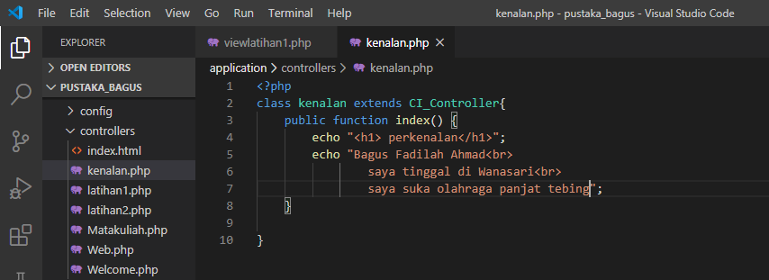

1. URL

<http://localhost/pustaka_bagus/index.php/kenalin>

1. Capture Hasil

